**100A PWM** Operation manual of two-way waterproof electric regulator

1. The dimensions are shown below**：**

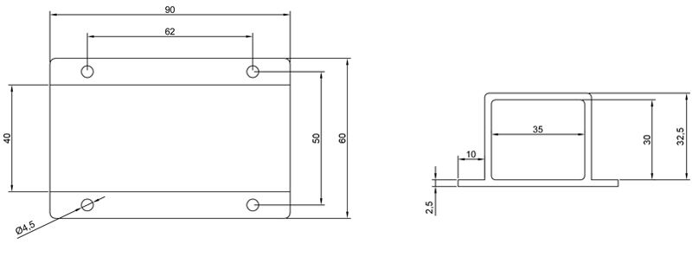

1. **performance parameter**
2. Description of continuous current: when the electric regulator is not potted in the air, the continuous current tested is 100A. The continuous current after potting is not strictly defined. Generally, for the electric regulator with underwater propeller, the reserved margin will be larger than that of the conventional aircraft model and vehicle model. Because the resistance of the propeller in the water is greater than that in the air and land, the current generated by the motor and the electric regulator is also relatively large, a large amount of heat will be generated when the load is loaded, and the electric regulator temperature will rise instantaneously. Because the electric regulator is fully sealed and waterproof, the only heat dissipation method is the electric regulator aluminum box, and it is necessary to soak the electric regulator in the water for heat dissipation. Pay attention to the positive pole of the power supply and do not touch the water. It is strictly prohibited to operate with load in the air, otherwise the electric regulator will be burned due to excessive temperature. The resulting damage is not covered by the warranty. The continuous current of the electric regulator is determined according to the actual ambient temperature.
3. The power dispatching can support 12s at most; Support forward and reverse, pulse width 1000us-2000us, median 1500us;

Current: 100A

Instantaneous maximum current: 120a (10s)

Supporting voltage: 21v-50v (lipo: 5-12s)

BEC:5.5V//8A

PWM: 1000-1500-2000us, 1500 is stop

Weight: 438g